

**Context:** Start-up

**Assessment Type:** Business Skills

**Task :** Produce a Business Model Canvas, Financial model of the business, and SWOT and PESTLE analysis.

**Task:** Produce your business model canvas, as well as a PESTLE and SWOT analysis and financial model (break even sales as well as cost and revenue structure).

**Due date**: Complete by Monday 28 October, with teacher added to your CANVA document (T4, Week 3) .

**Capabilities to develop in this topic and phase of your business innovation**:

* propose, develop, and test possible revenue models and pricing strategies within the business model
* analyse and communicate the cost structures associated with the business model, identifying fixed and variable costs, price of product, and apply the break even sales model
* determine cash flow requirements for their start-up business, including initial funding/capital and point of sale or terms of trade for customers.
* analyse and respond to information that confirms or denies their initial hypotheses and assumptions
* identify metrics and key performance indicators that will be used to monitor the start-up business model against planned expectations.
* Analyse the strengths and weaknesses of your business model, as well as the external opportunities and threats, using SWOT and PESTLE Analysis.

**The task**: Use CANVA to produce an infographic that contains the following:

Page 1 - Title page with Your logo, business name and tag line.

Page 2 - A Business Model Canvas summarizing the key partners, resources, activities, distribution channels, customer relationships, customer segments, revenue streams, cost structure, value proposition and customer segments

Page 3 – 7 – separate pages showing detailed strategies and research for key partners, resources, activities, distribution channels, customer segments

Pages 8-10 – Finances showing workings for revenue streams, cost structure, break even analysis

Page 11 – Value proposition canvas

Page 12 – PESTLE and SWOT Analysis

**Format:** Each group is to have a CANVA document as per the above task outline, with each student and the teacher added via <https://www.canva.com/>

1. **Sign up Canva with student email.**
2. One member in your group should create a template and share it to others to edit. To start, click **Create a design**



1. Choose **presentation** in the list

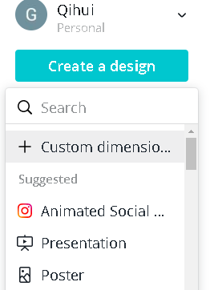

1. **To make a business model canvas structure,** use the square shapes in the element category. Adjust the square into appropriate shape, and add more.

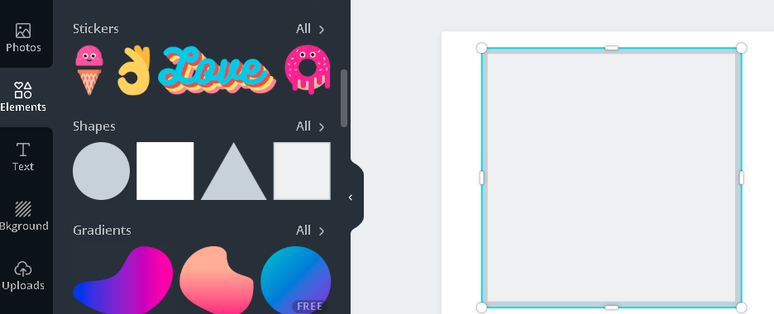

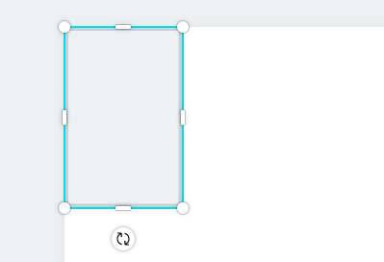 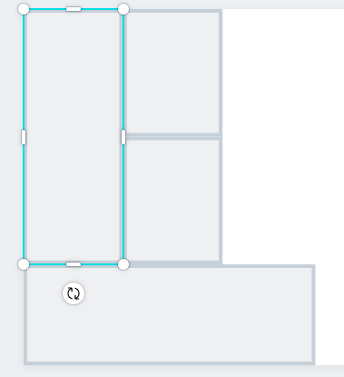

1. **Add text box for each building blocks**, and for business name at the top. Now you have a template for business model canvas.

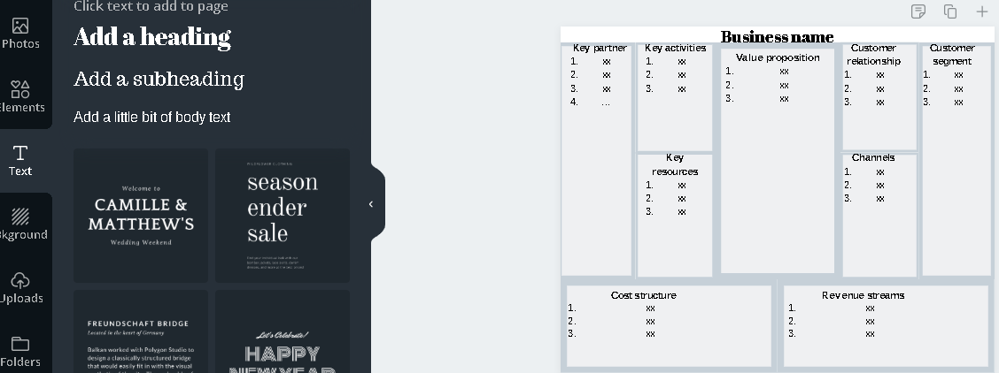

1. **Add more pages** and makes it like a powerpoint, then share this to your group member. Now it`s time to work as a group.



| - | Finding and Solving Problems | Contextual Application | Analysis and Evaluation |
| --- | --- | --- | --- |
| A | Purposeful and sustained exploration of problems or needs using a customer-focused approach.  Creative generation of possible solutions to problems or needs using a customer-focused approach. | Highly effective contextual application of financial awareness and decision-making skills.  Strategic application of business and financial information to develop and communicate business models.  Perceptive contextual application of communication and/or collaboration skills. | Insightful exploration and analysis of opportunities presented by digital and emerging technologies.  Insightful evaluation of the effectiveness of business models. |
| B | Purposeful exploration of problems or needs using a customer-focused approach.  Mostly creative generation of possible solutions to problems or needs using a customer-focused approach. | Effective contextual application of financial awareness and decision-making skills.  Purposeful application of business and financial information to develop and communicate business models.  Well-considered contextual application of communication and/or collaboration skills. | Well-considered exploration and analysis of opportunities presented by digital and emerging technologies.  Well-considered evaluation of the effectiveness of business models. |
| C | Considered exploration of problems or needs using a customer-focused approach.  Some creativity in generation of possible solutions to problems or needs using a customer-focused approach. | Some effectiveness in application of financial awareness and decision-making skills.  Competent application of business and financial information to develop and communicate business models.  Considered contextual application of communication and/or collaboration skills. | Considered exploration and analysis of opportunities presented by digital and emerging technologies.  Competent evaluation of the effectiveness of business models. |
| D | Superficial exploration of problems or needs using a customer-focused approach.  Some generation of possible solutions to problems or needs using a customer-focused approach. | Developing financial awareness and decision-making skills.  Inconsistent application of business and financial information to develop and communicate business models.  Contextual application of communication and/or collaboration skills. | Some exploration and description of opportunities presented by digital and emerging technologies.  Some description of and reflection on the effectiveness of business models. |
| E | Limited exploration of problems or needs using a customer-focused approach.  Attempted generation of possible solutions to problems or needs using a customer-focused approach. | Emerging financial awareness and decision-making skills.  Attempted application of business and financial information to develop and communicate business models.  Limited application of communication and/or collaboration skills. | Attempted exploration and description of opportunities presented by digital and emerging technologies.  Description of the effectiveness of business models. |